ADDESSA

Motorpool Webportal User's Manual

(Admin)
LOGIN PAGE

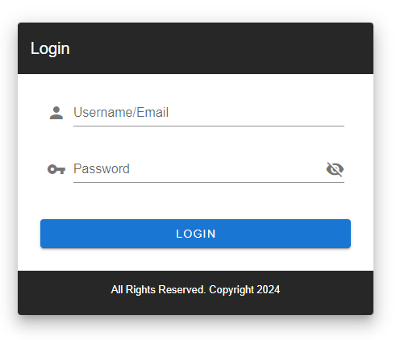
Step 1. Open your prefered web browser. In the address bar, enter the URL for Motorpool Webportal: http://192.168.1.236:3000/#/login

Step 2: Enter your credentials in the "Username" or "Email" field, enter the username or email address associated with your account. Also, in the "Password" field, enter your password. Ensure that you type it accurately, as passwords are case-sensitive.

Step 3: After entering your credentials, click the "LOGIN" button to access your account.

SETTING UP SAP DATABASES

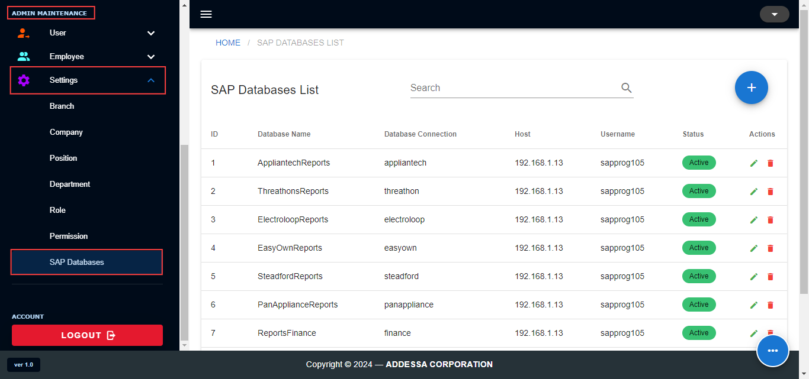
We need to check the active SAP Databases under Admin Maintenance > Settings > SAP Databases. We will use these active databases in syncing vehicles data in our Database from SAP.

Adding SAP Database

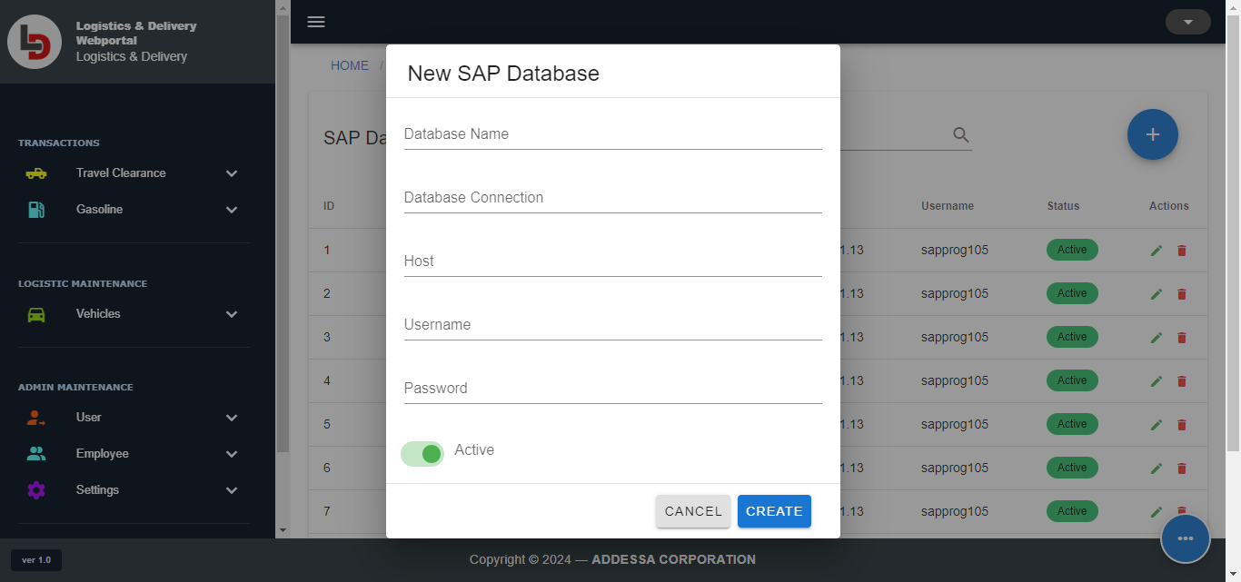
Step 1. Click the add button. The create dialog will appear.
Step 2. Input the needed fields such as Database Name, Connection, host, username, and password. Step 3. Select active or inactive. Inactive option is used if the database is unavailable.
Step 4. Click create.

Updating SAP Database

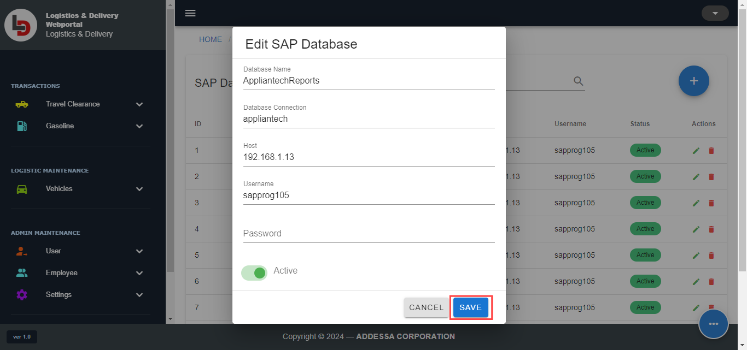
Step 1. Under Actions in the table, click the pencil icon you want to delete. The edit dialog will appear on the screen.
Step 2. Update necessary fields including password and active or inactive option.
Step 3. Click save button.

Deleting SAP Database

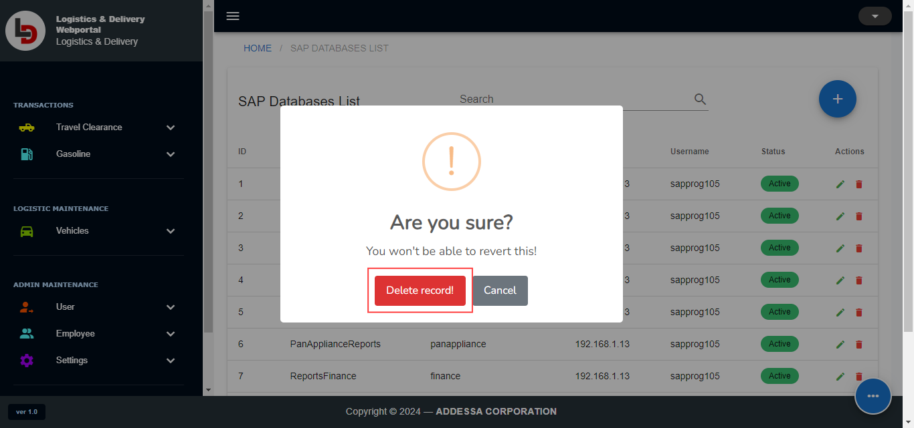
Step 1. Under Actions in the table, click the trash icon of the record you want to delete. The confirmation dialog will appear.
Step 2. Click delete record.
SYNCING VEHICLES
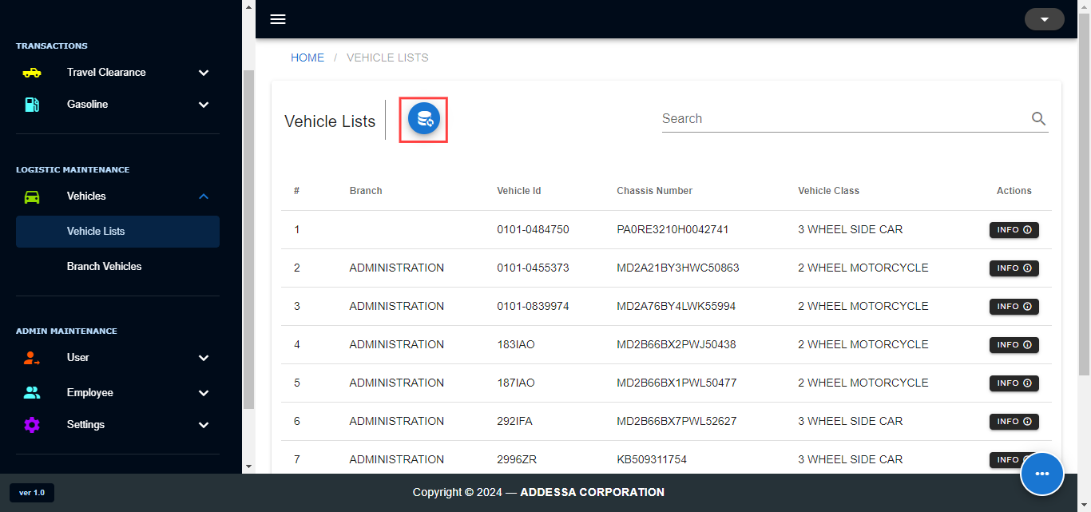

Syncing vehicles will update the vehicle information from the active SAP Database in the setting. To sync it, go to Vehicles > Vehicle Lists.

Syncing Database

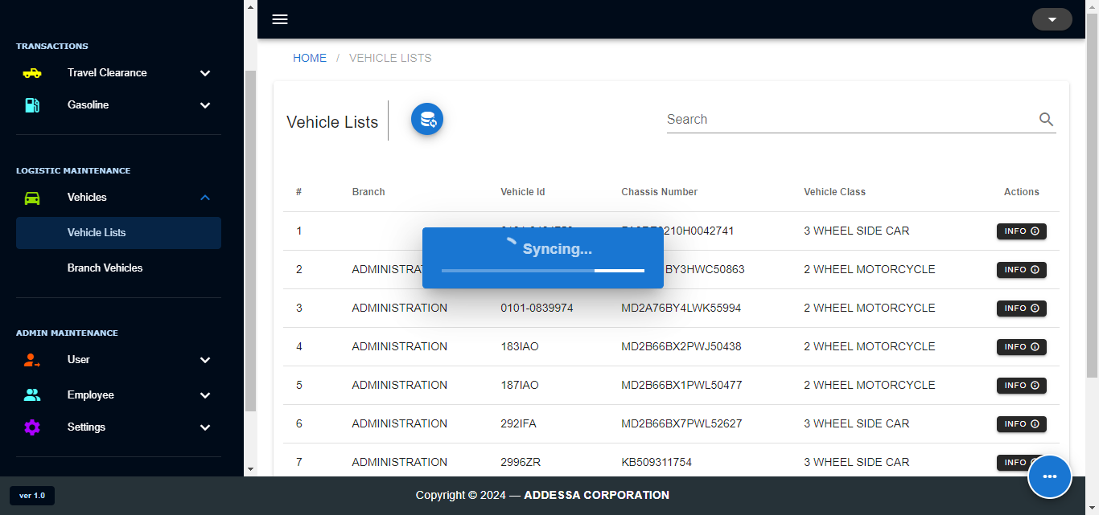

Step 1. Click the Sync Button
Step 2. Wait for the syncing to be finished. The alert success will pop up once the syncing is done.
SETTING UP VEHICLE ACCOUNTS

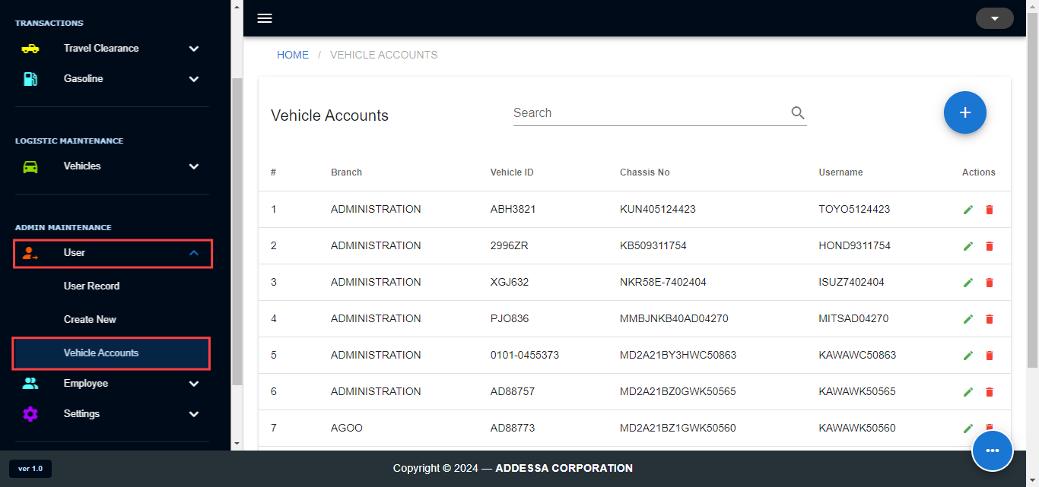
Vehicle accounts are the accounts used by drivers. They will use these accounts to request Purchase Orders (PO) for their gasoline. Under Admin Maintenance, select User > Vehicle Accounts.

Adding of Vehicle Accounts

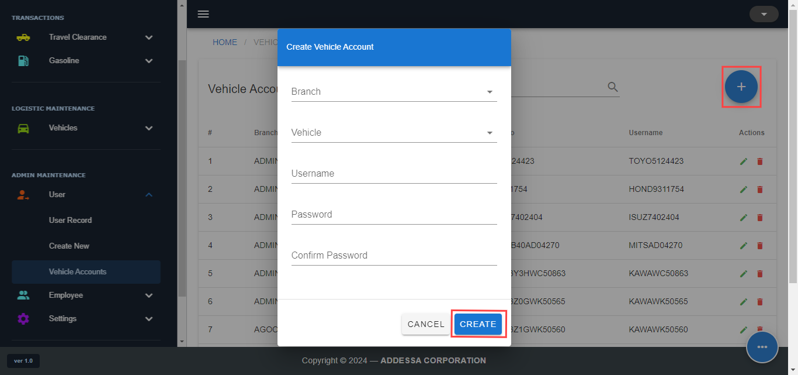
Step 1. Click Add Button
Step 2. Fill in the necessary fields when creating vehicle accounts, such as branch, vehicle, username, password, and confirm password.
Step 3. Click “CREATE” button.

Updating Vehicle Accounts

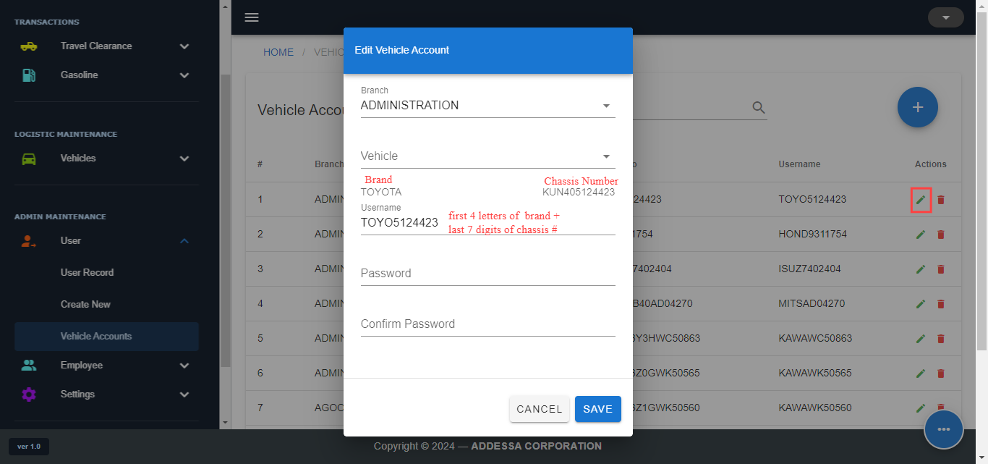
Step 1. Under Actions in the table, click the pencil icon you want to edit. The edit dialog will appear on the screen.
Step 2. Update necessary fields but the branch and the vehicle field was set to readonly to avoid conflict. Also, password is optional in update.
Step 3. Click save button.

Deleting Vehicle Accounts

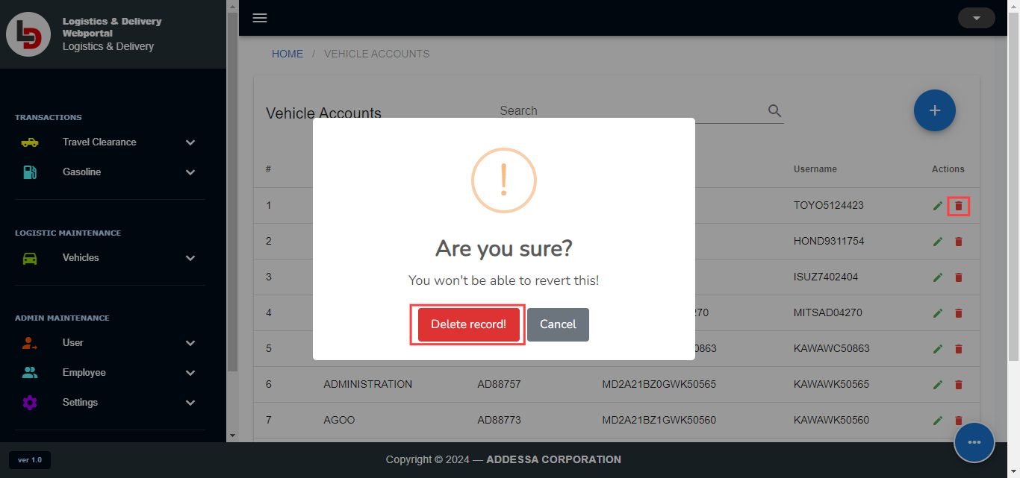
Step 1. Under Actions in the table, click the trash icon of the record you want to delete. The confirmation dialog will appear.
Step 2. Click delete record.
GASOLINE PAGE

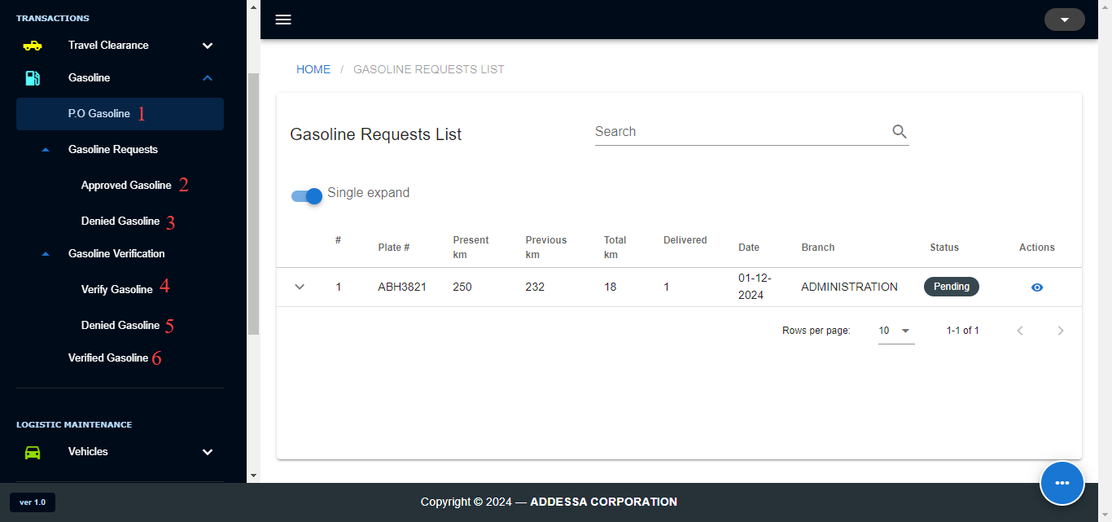
Navigate to 'Gasoline' under Transactions. It comprises six (6) subpages: PO Gasoline, Approved Gasoline, Denied Gasoline (Approval), Verify Gasoline, Denied Gasoline (Verification), and Verified Gasoline.

PO GASOLINE PAGE

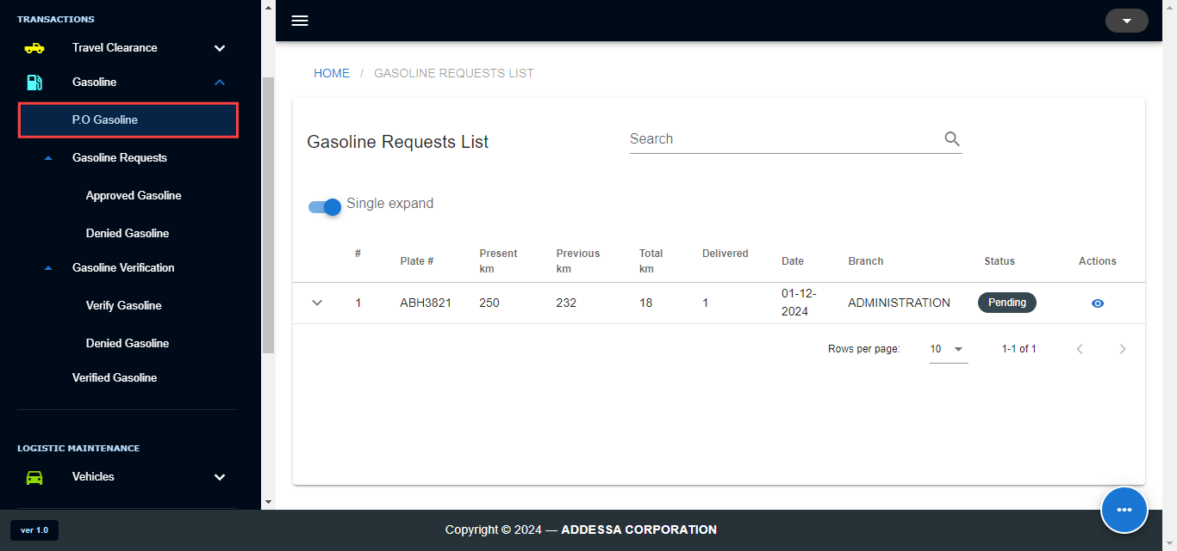
On the "PO Gasoline" page, all gasoline requests from the branch are displayed. This page serves as the platform where you can either approve or deny drivers' gasoline requests. Approved requests will be redirected to the "Approved Gasoline" page, while denied requests will be directed to the "Denied Gasoline" page.

APPROVE GASOLINE REQUEST

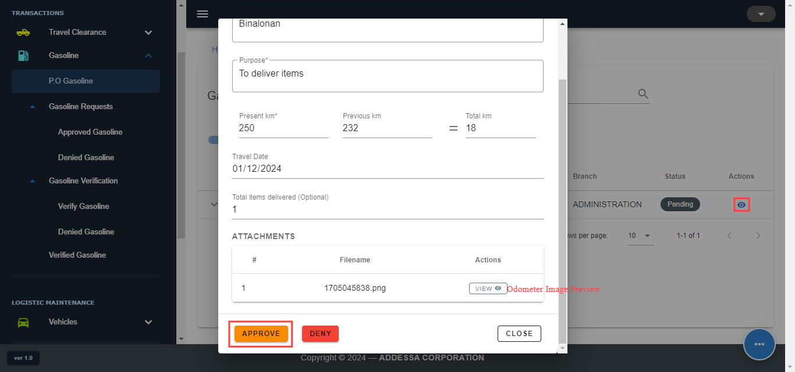
Step 1. Click the eye icon under the Actions column in the table, the request dialog will pop up.
Step 2. Check the details of the driver's PO request.
Step 3. Once checked, click the approve button. Another dialog will pop up to get the PO number.
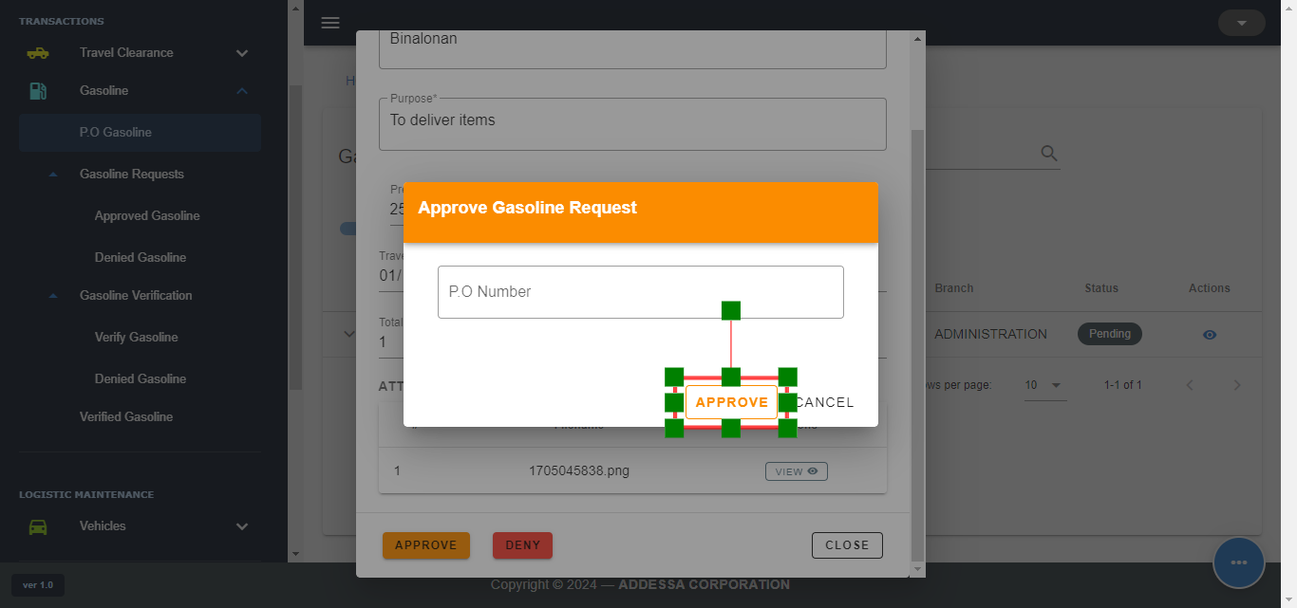

Step 4. Enter PO number then click “Approve”. The confirmation will pop up.
Step 5. Click Approve.

DENY GASOLINE REQUEST

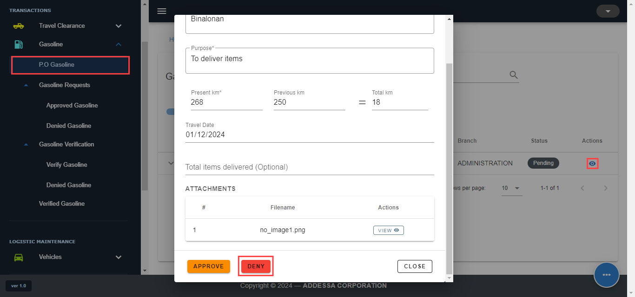
Step 1. Click the eye icon under the Actions column in the table, the request dialog will pop up.
Step 2. Check the details of the driver's PO request.
Step 3. Once checked, click the deny button. Another dialog will pop up.
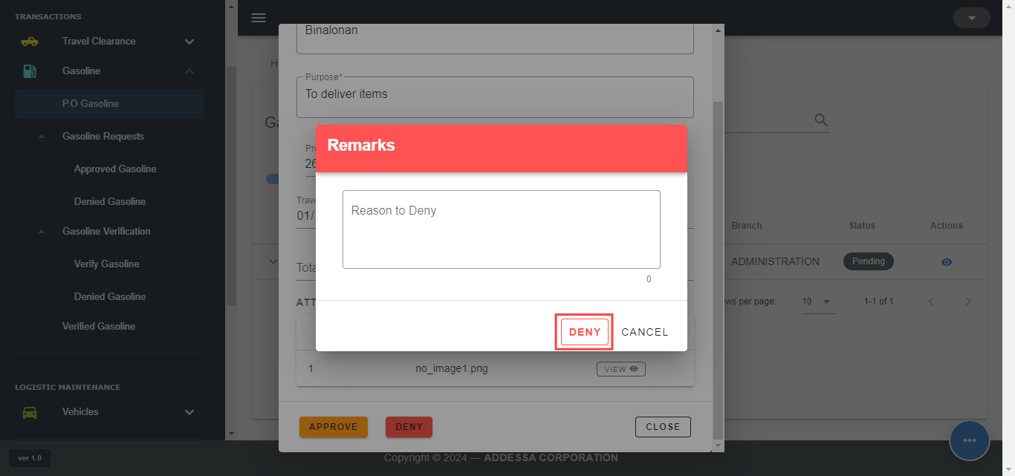
Step 4. Enter your Reason to deny then click “Deny”. The confirmation will pop up.
Step 5. Click Deny.

APPROVED GASOLINE PAGE
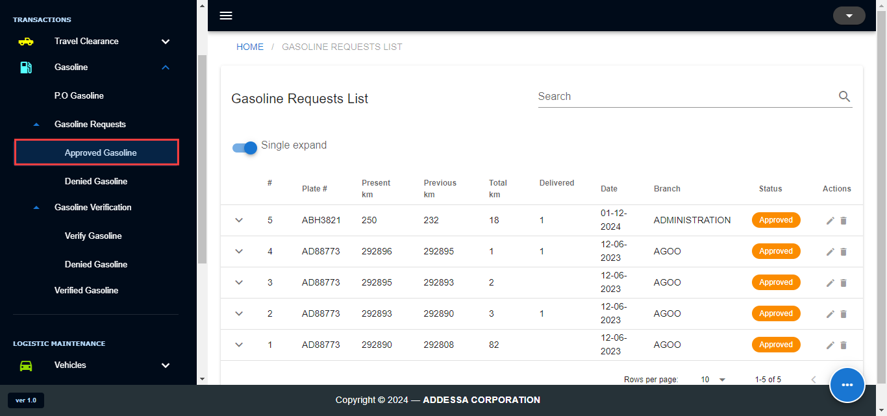
On the "Approved Gasoline" page, you can view all the approved gasoline requests. At this page, your role is to observe and await the driver's completion of the necessary data for the next process—the verification process.

DENIED GASOLINE PAGE
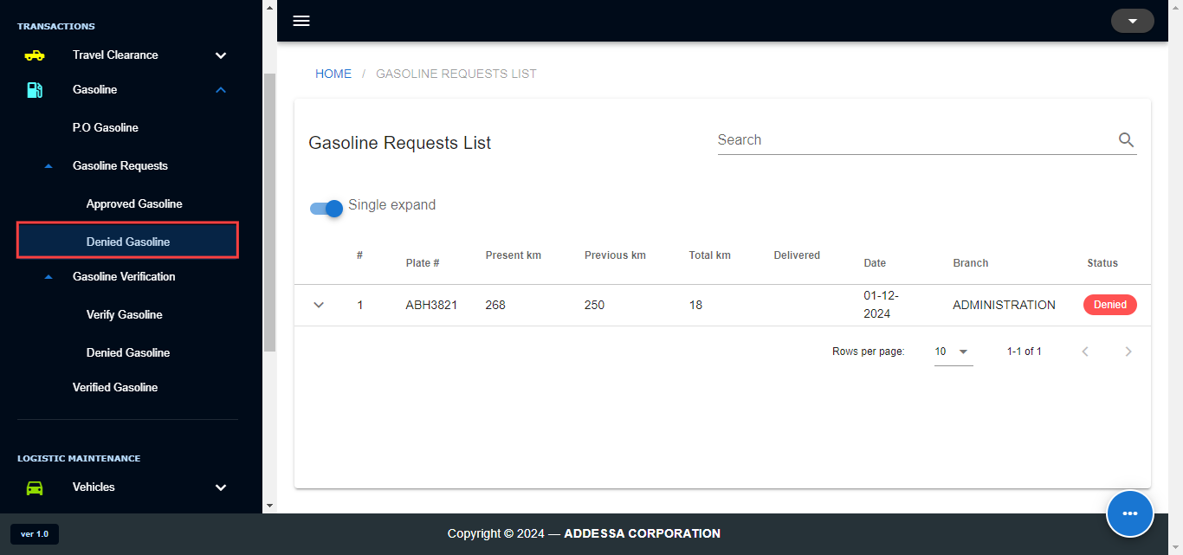
On the "Denied Gasoline" page, you can review all the denied gasoline requests. This page displays a list of denied requests, providing drivers with reasons for the denials. This page allows drivers to update their requests, which will then be redirected to the "PO Gasoline" page for reconsideration.

VERIFY GASOLINE PAGE
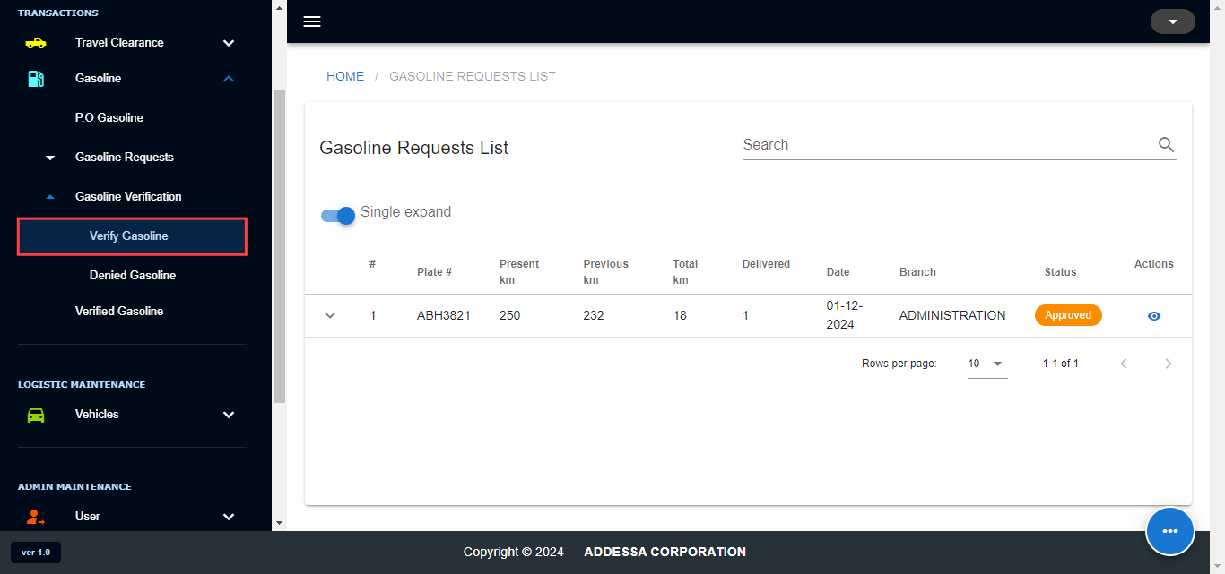
On the "Verify Gasoline" page, displays all of the approved requests updated by the drivers. The requests is now subjected to verification process.

VERIFY GASOLINE REQUEST
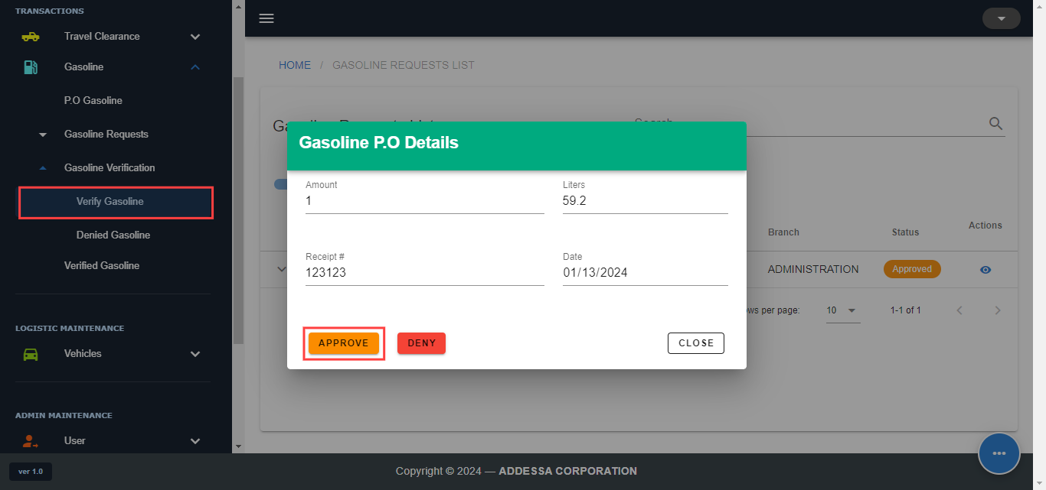
Step 1. Click on the eye icon under Actions in the table.
Step 2. Check for the details if it is correct.
Step 3. Click "APPROVE". The confirmation dialog will appear.
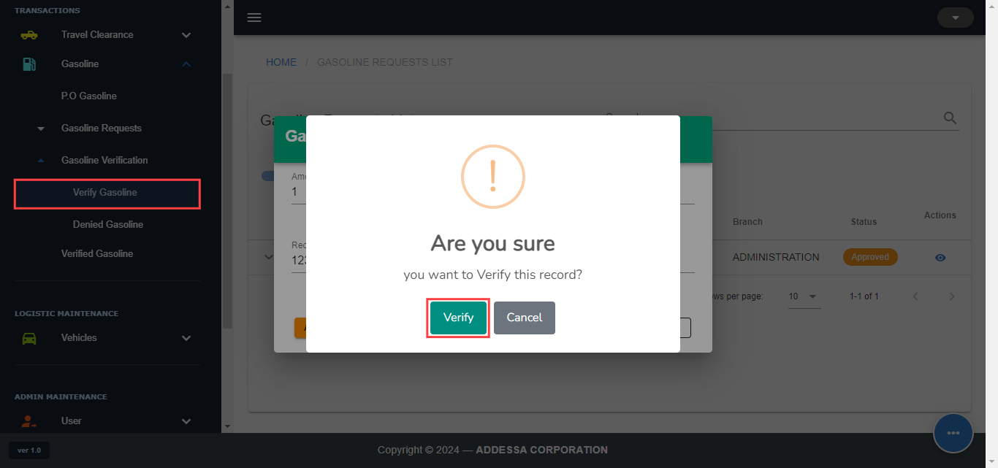
Step 4. Click "Verify".
DENY GASOLINE REQUEST
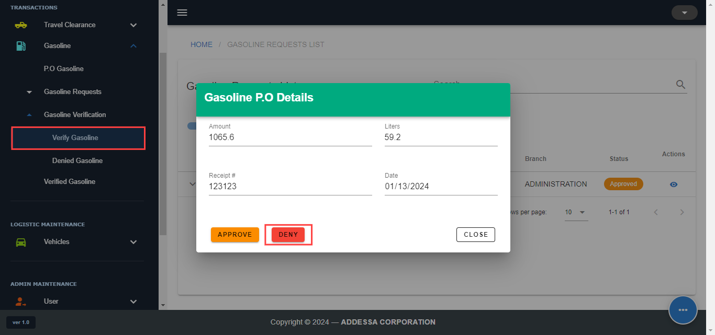
Step 1. Click on the eye icon under Actions in the table.
Step 2. Check for the details if it is incorrect.
Step 3. Click "DENY". The confirmation dialog will appear.
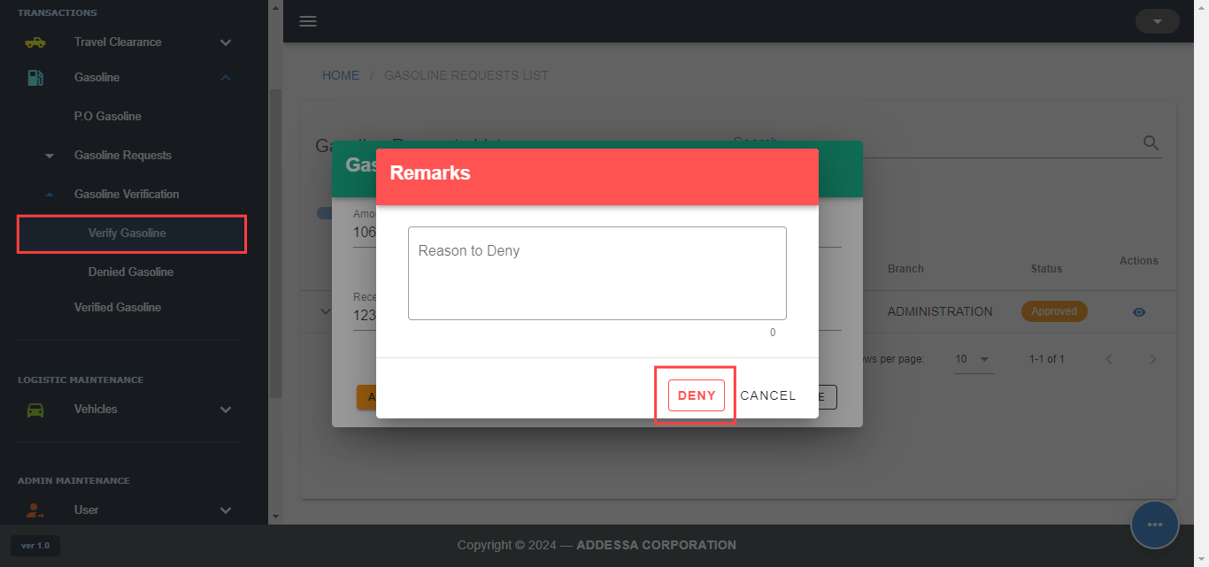
Step 4. Click "DENY".
DENIED GASOLINE PAGE
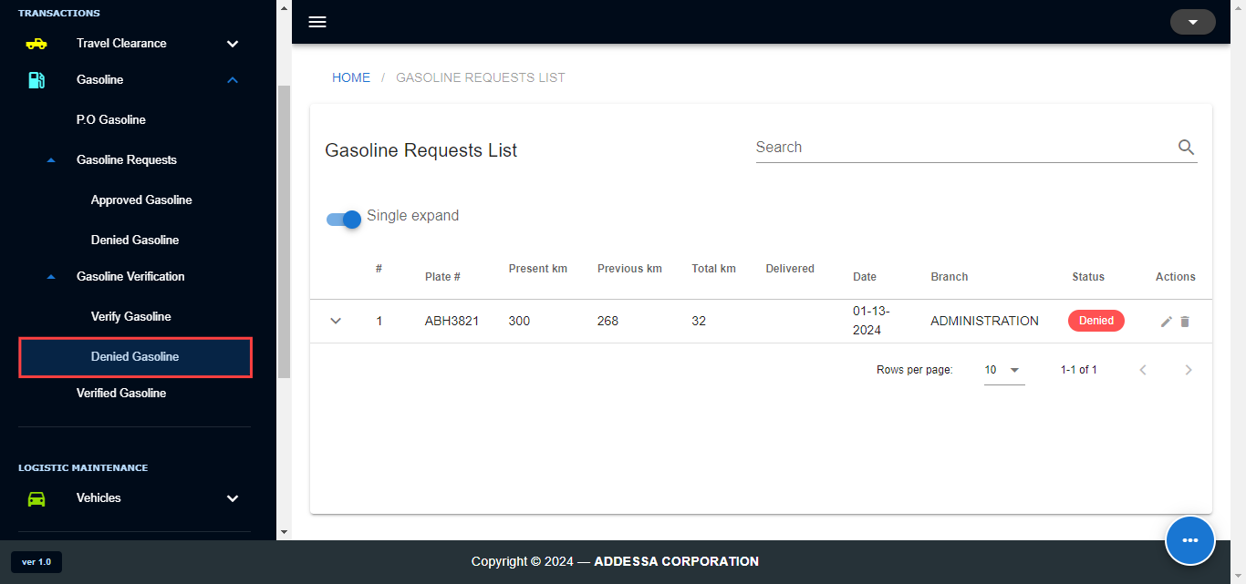
On the "Denied Gasoline" page, all denied requests during the verification process are displayed. While this page serves as a viewing platform for you to see the list of denied requests in verification process, it also allows drivers to update their requests for reconsideration.
VERIFIED GASOLINE PAGE

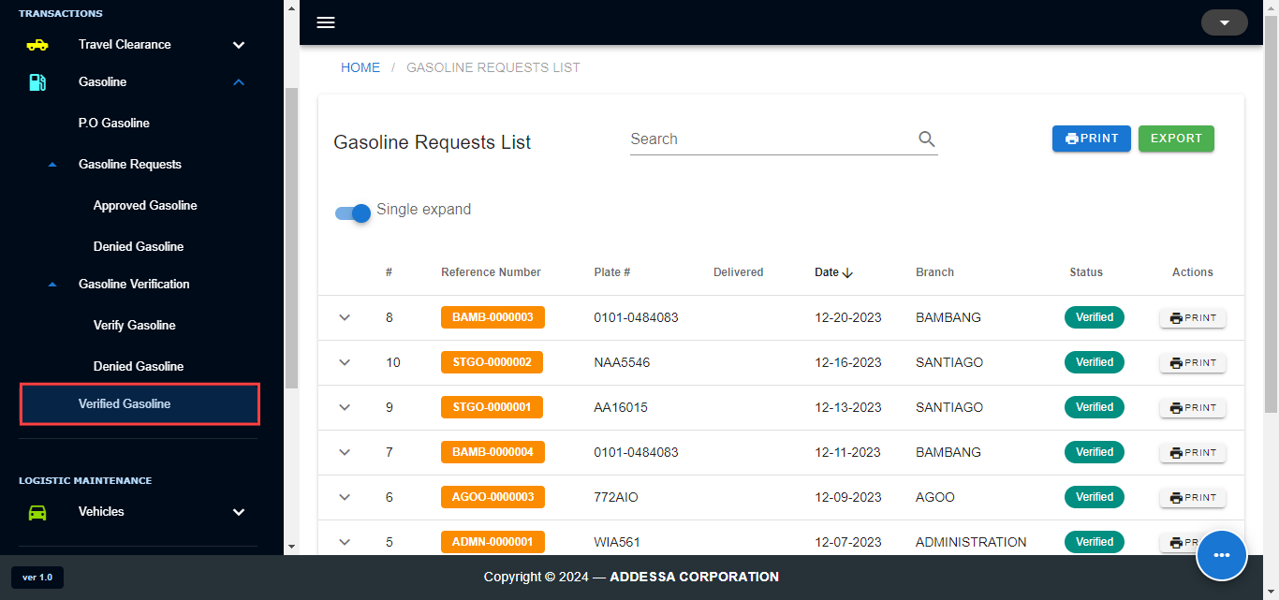
On the "Verified Gasoline" page, all successfully verified requests from the verification process are displayed. This page provides you with the capability to print the gasoline request along with a summary of gasoline details. The format of the printed report can be customized based on your preference, either in Excel or PDF format.

